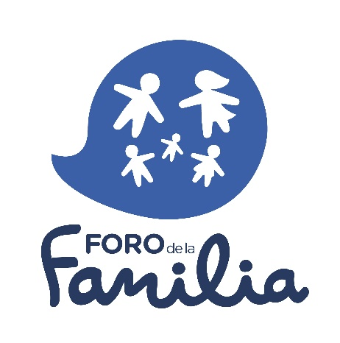
- “The best interests of the child shall be the guiding principle of those responsible for his education and guidance; that responsibility lies in the first place with his parents”. Principle VII Declaration of the Rights of the Child.

- “Parents have a prior right to choose the kind of education that shall be given to their children”. Art. 26.3 UDHR.

- “The freedom to found educational establishments with due respect for democratic principles and the right of parents to ensure the education and teaching of their children in conformity with their religious, philosophical and pedagogical convictions shall be respected”. Art. 14.3 Charter of Fundamental Rights of the EU.

FOR THE GUARANTEE OF FREEDOM OF EDUCATION IN ALL MEMBER STATES OF THE EU.

Considering the prior right of parents to choose the kind of education that shall be given to their children, according to Article 26.3 of the Universal Declaration of Human Rights.

Considering the freedom to found educational establishments and the right of parents to ensure the education of their children in conformity with their convictions, according to Article 14.3 of the Charter of Fundamental Rights of the European Union.

Considering that the responsibility of the education of children lies in the first place with their parents, according to Principle VII of the Declaration of the Rights of the Child.

Considering that the right of parents to ensure their children education and teaching in conformity with their own religious and philosophical convictions shall be respected, according to Article 2 of Protocol 1 of the European Convention on Human Rights.

Considering the liberty of parents to choose for their children schools, other than those established by the public authorities, according to Article 13.3 of the International Covenant on Economic, Social and Cultural Rights.

We call all the Members of the European Parliament to express their commitment to freedom of education by adhering to this statement in defense of:
- A non-politicized education.
- The guarantee of fundamental rights and freedoms of parents and schools.
- The achievement of the highest quality of the educational system.

